

**Bangabandhu Sheikh Mujibur Rahman Digital University, Bangladesh**

**Faculty of Cyber Physical Systems**

**Department of Internet of Things and Robotics Engineering**

**B.Sc. in Internet of Things and Robotics Engineering**

Course Title:Software Engineering Lab

Course Code: ICT 4354

## Project Requirements

**Submitted to:**

# Shifat Ara Rafiq

Lecturer,

Department of Software Engineering, BDU.

**Submitted By:**

Afsana Mim 2001027

Abidul Islam Alif 2001040

### Saadman Jawad Naveed 2001043

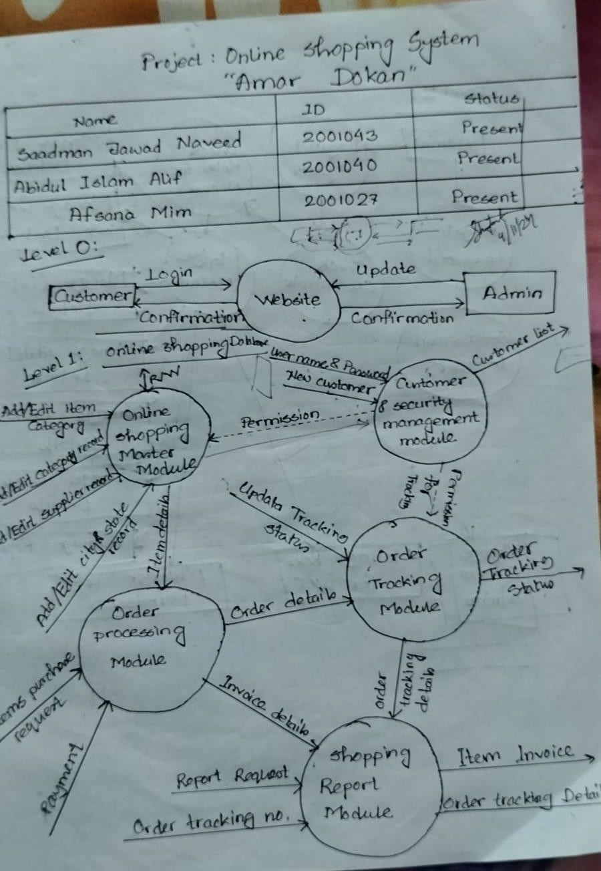

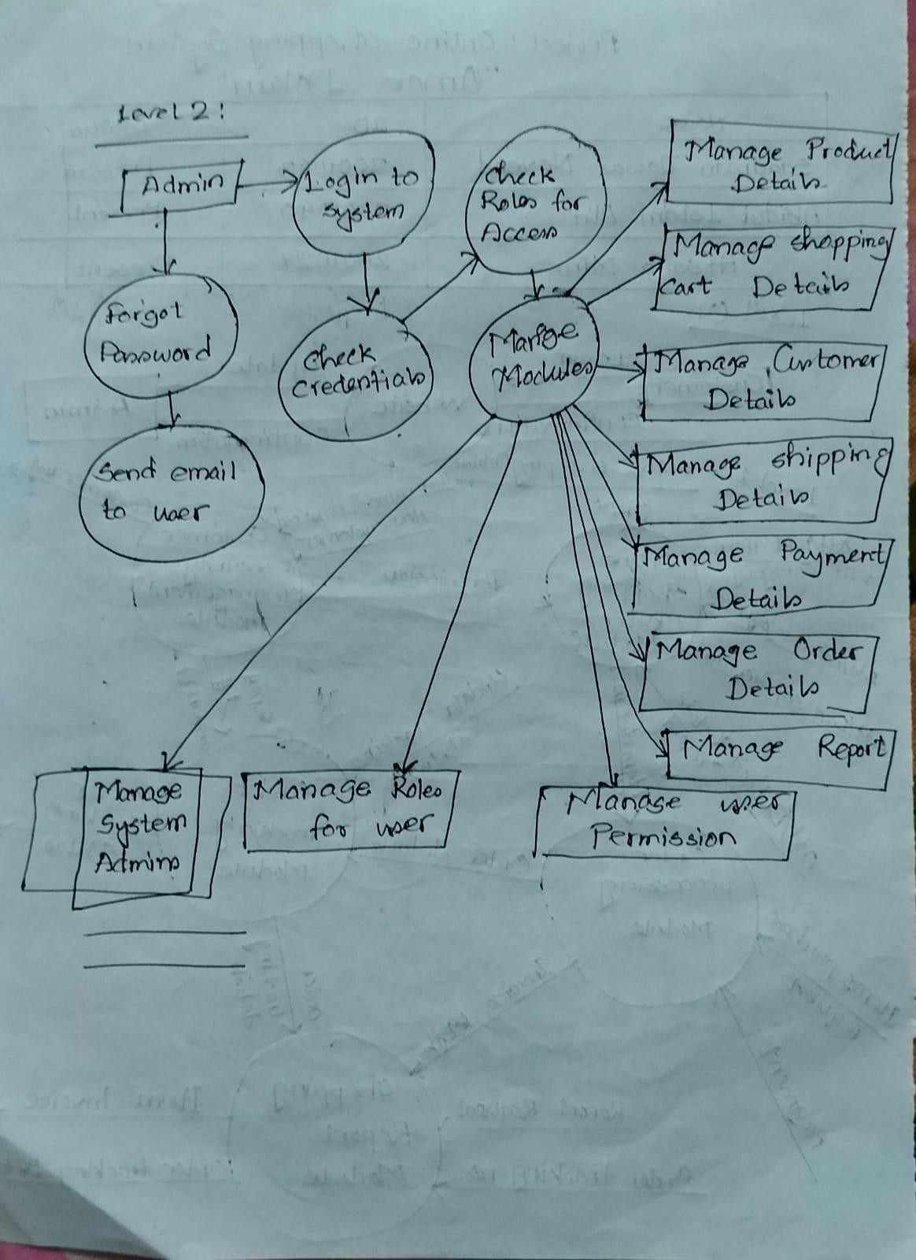

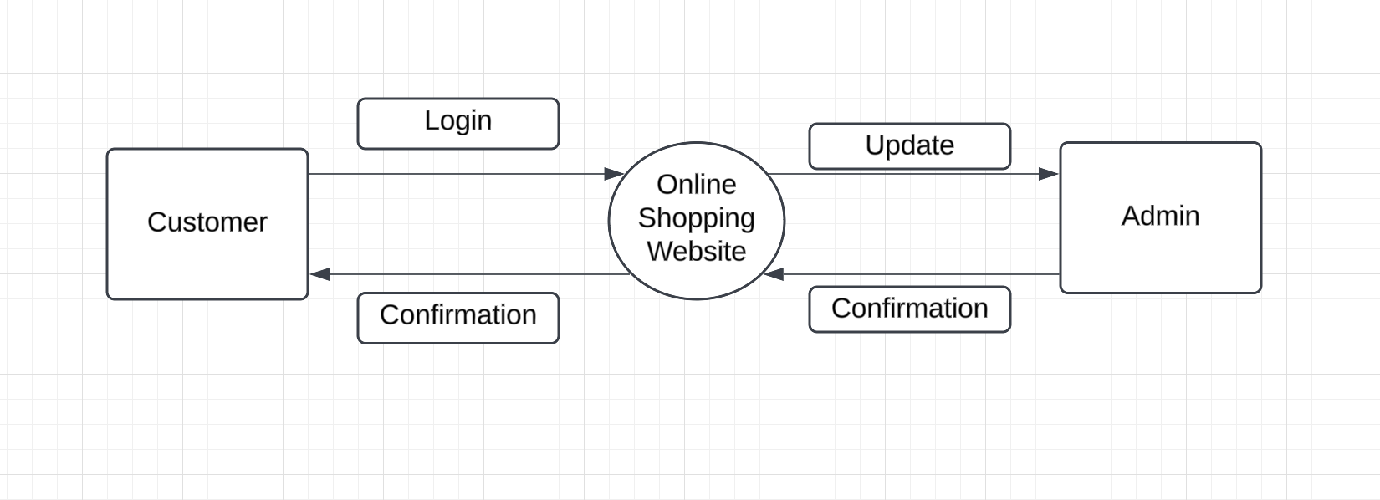DFD level 0 in LucidChart :

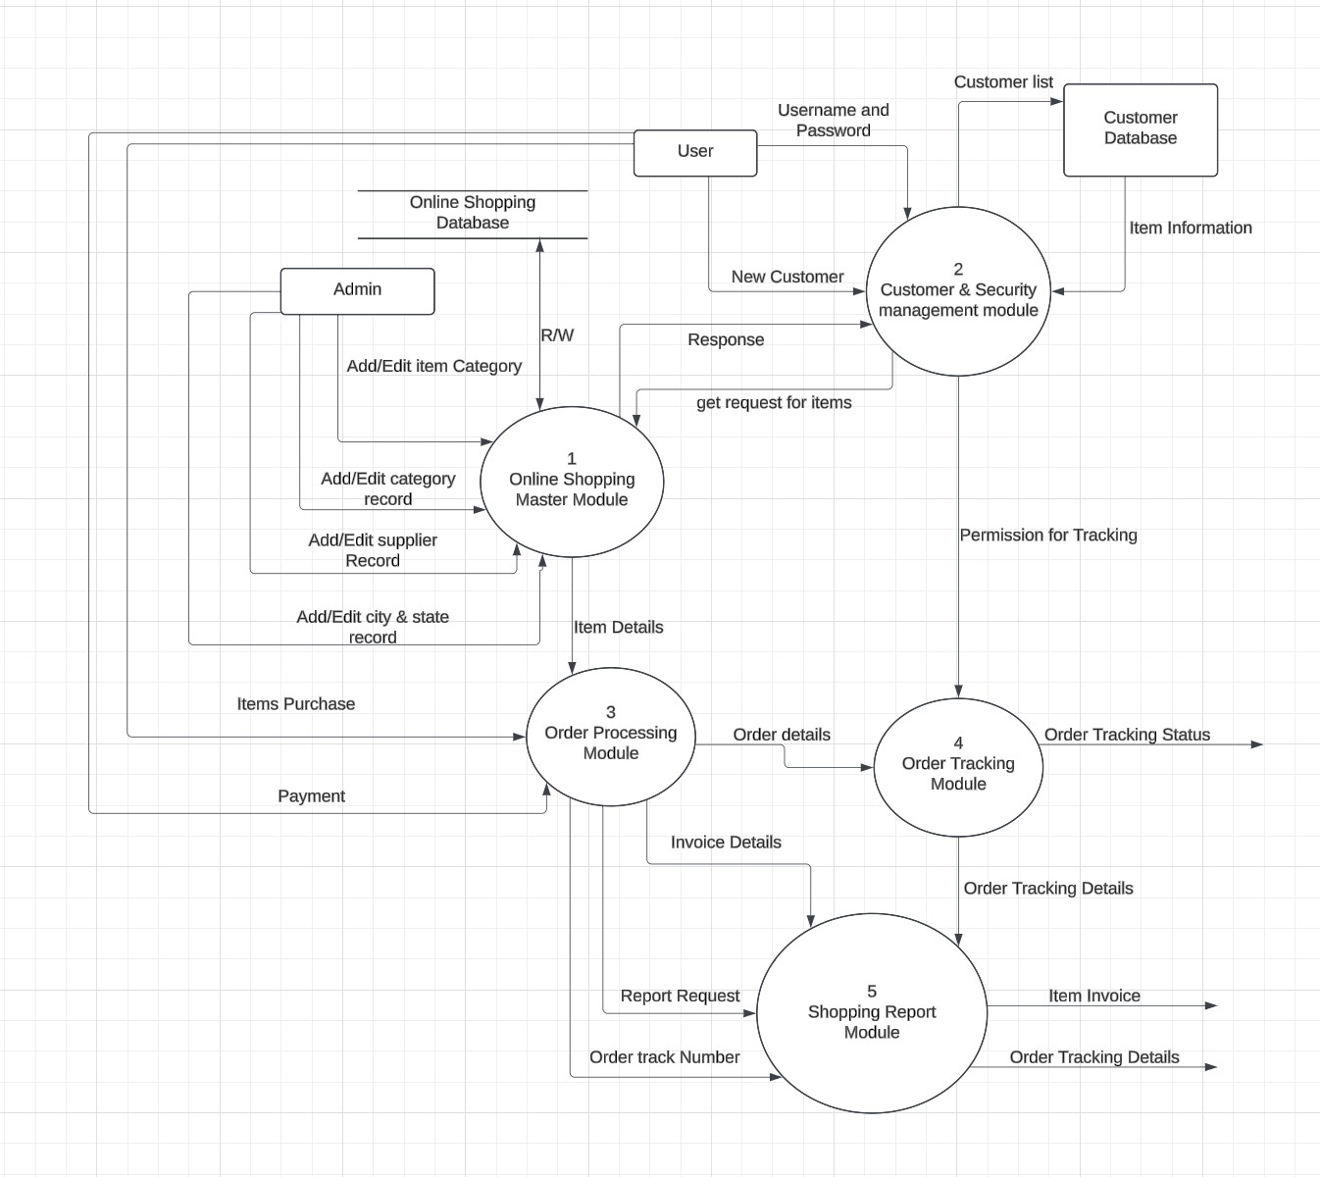DFD level 1 in LucidChart :

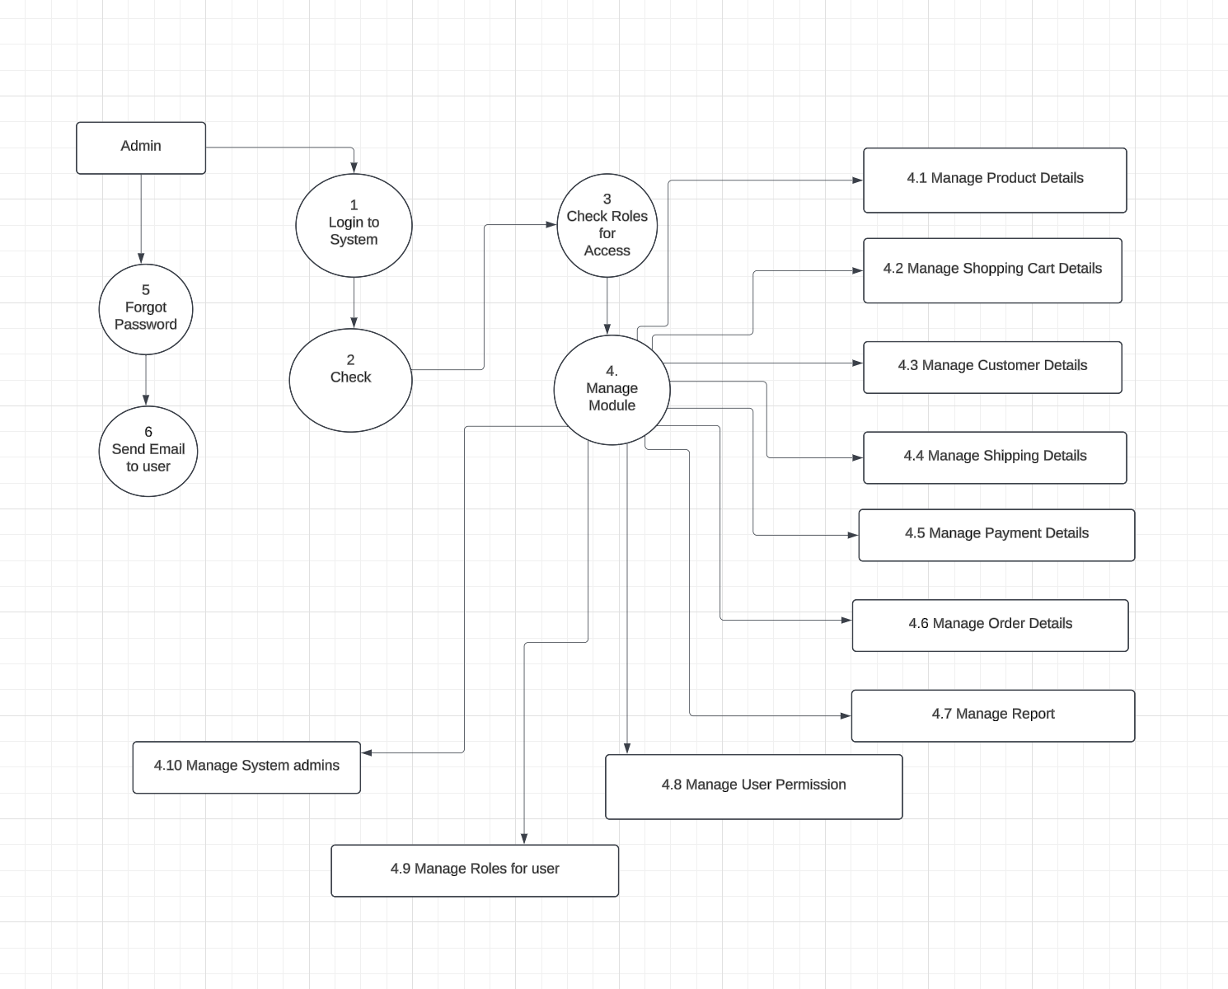DFD level 2 in LucidChart: